**ABB - Tacora Custom Setup**

## Custom Check Print

1. Setup custom table file control records in MSO010

|  |  |  |  |
| --- | --- | --- | --- |
| Table Code | Description | Associated Value | Active |
| +CHK | Check Print Dynamic Parameters | U1850NYY | Y |
| +CHK01 | Max. records per page | 0201YNUMBER | Y |
| +CHK02 | First check number to start wit | 1003YNUMBER | Y |

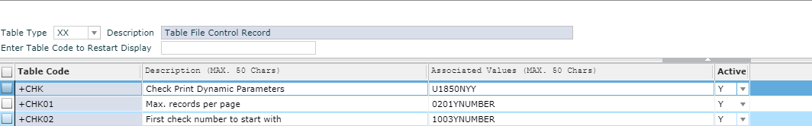

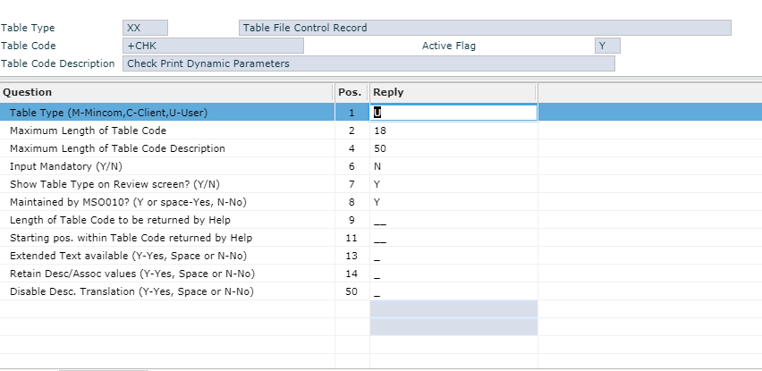

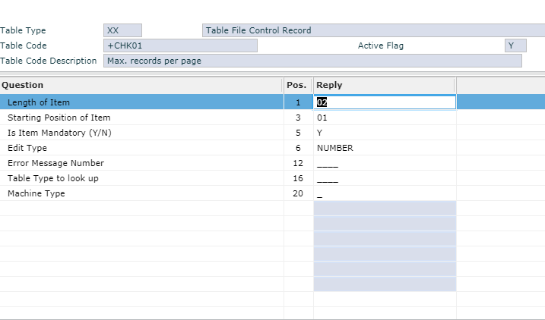

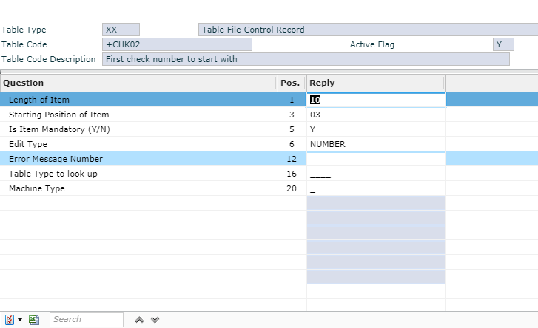

1. Setup the custom table codes for the +CHK Table Type. This is used to hold the number of detail lines per page and the starting check number.

|  |  |  |  |
| --- | --- | --- | --- |
| Table Code | Description | Associated Value | Active |
| 000220011803574 | Bank of Montreal CAD | 280000002000 | Y |
| 000220014635560 | Bank of Montreal USD | 280000001000 | Y |
| 75000019201295331 | JPMorgan Chase Bank, N.A. | 280000004000 | Y |

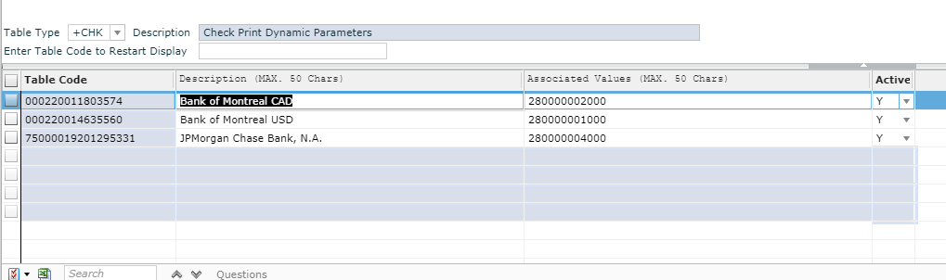

1. Setup custom table file control records in MSO010

|  |  |  |  |
| --- | --- | --- | --- |
| Table Code | Description | Associated Value | Active |
| Bank Addresses | Bank Addresses | U1850NYY | Y |
| +BNK01 | Bank Address Line 1 | 3001NALPHA | Y |
| +BNK02 | Bank Address Line 2 | 1931NALPHA | Y |

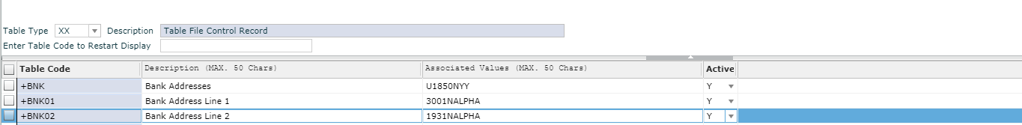

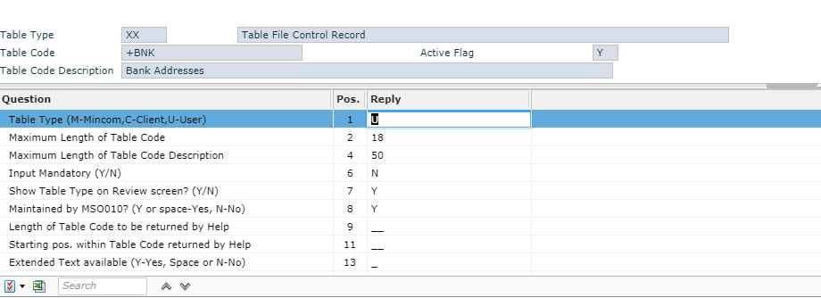

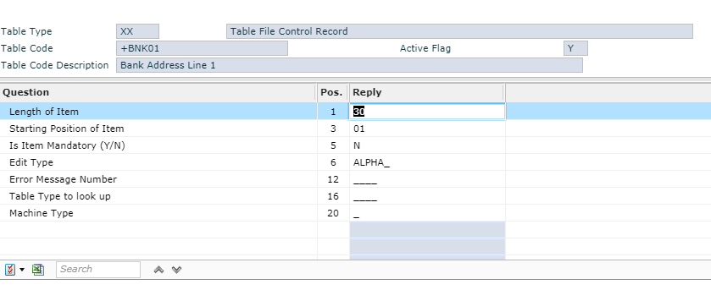

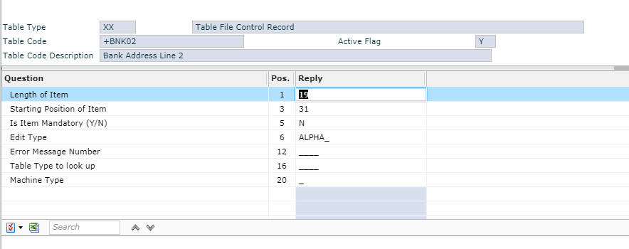

1. Setup the custom table codes for the +BNK Table Type. This is used to hold the number of detail lines per page and the starting check number.

|  |  |  |  |
| --- | --- | --- | --- |
| Table Code | Description | Associated Value | Active |
| 000220011803574 | BMO BANK OF MONTREAL | 100 KING ST. W. TORONTO, ON M5X 1A3 | Y |
| 000220014635560 | BMO BANK OF MONTREAL | 100 KING ST. W. TORONTO, ON M5X 1A3 | Y |
| 75000019201295331 | JPMorgan Chase Bank, N.A. | MILWAUKEE, WI | Y |

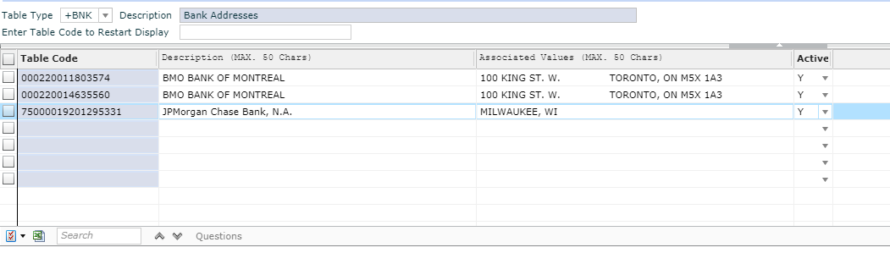

1. Setup custom program definition in MSE081

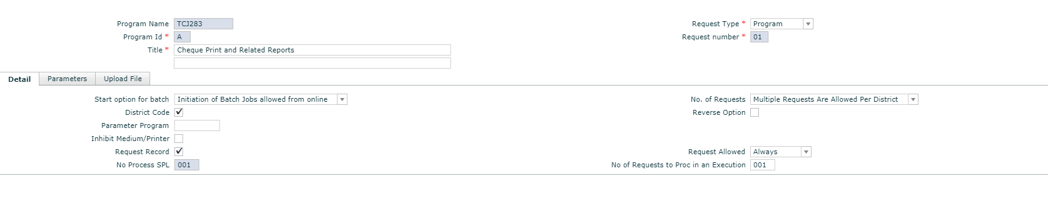

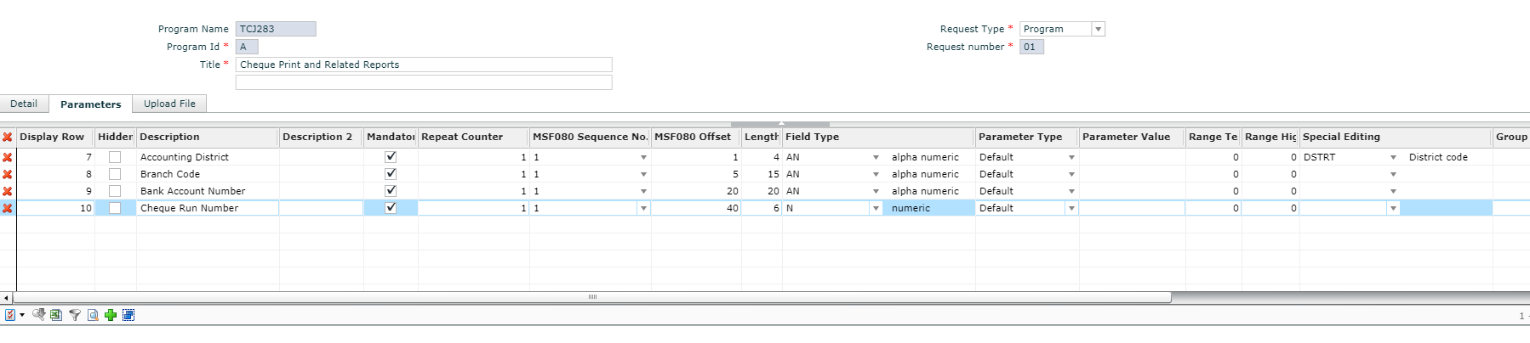

1. Copy the following files to /appliance/data/conf/git-repos/customer-software
2. /reporting/jasper/src/tcj283.zip
3. /lib/micr-font.jar
4. /lib/cheque-util.jar

## Custom PO Print

1. Setup custom program definition in MSE081. Open MSJPOP and save as TCJPOP

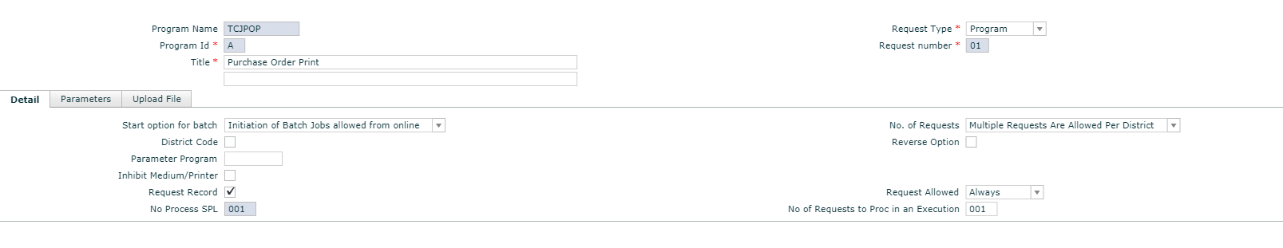

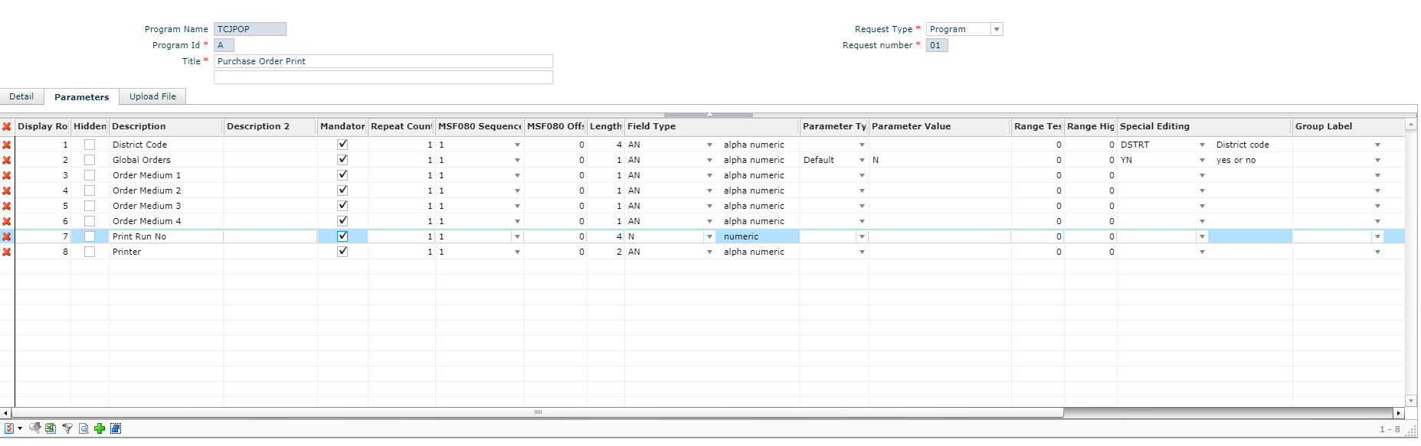

1. Create a Substitute Requests using MSO010, TableType: SR

|  |  |  |  |
| --- | --- | --- | --- |
| Table Code | Description | Associated Value | Active |
| MSJPOP | Purchase Order Print | TCJPOP | Y |

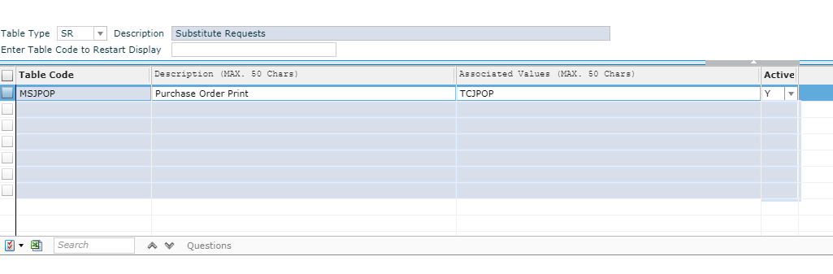

1. Copy the following files to /appliance/data/conf/git-repos/customer-software
2. /reporting/jasper/src/tcjpop.zip